**Aim : Design the following**

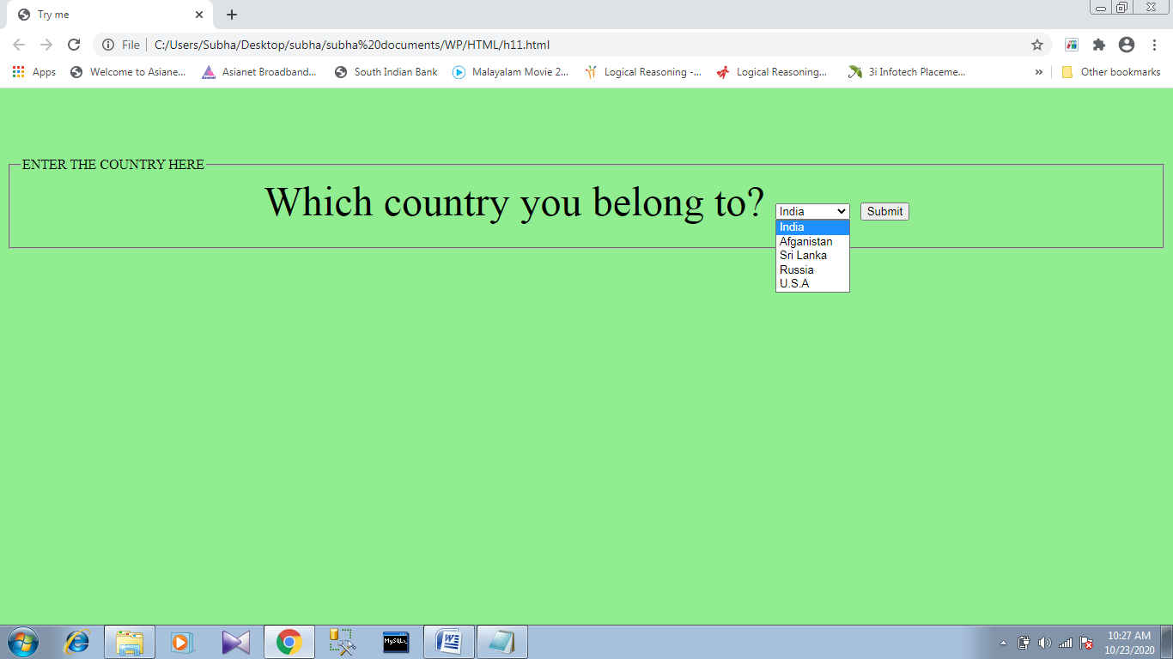

**Source code :**

<!DOCTYPE html>

<html>

<body style="background-color:LightGreen;" >

<fieldset>

<legend><h6>ENTER THE COUNTRY HERE</h6></legend>

<form action="" method="post"><center>

<b>Which country you belong to?</b>

<select id="name" name="name">

<option value="India">India</option>

<option value="Afganistan">Afganistan</option>

<option value="Sri Lanka">Sri Lanka</option>

<option value="Russia">Russia</option>

<option value="U.S.A">U.S.A</option>

</select>

<input type="submit" value="Submit"></center>

</form>

</fieldset>

</body>

</html>